A VERY SPECIAL THANK YOU TO OUR AMAZING INDIVIDUAL PERFORMANCE SPONSORS:

Russell, Kraft, & Gruber and
Ken & Louise Hess

It is the generous support of these loyal businesses and donors that keep help keep EPAC alive.

A VERY SPECIAL THANK YOU TO OUR AMAZING INDIVIDUAL PERFORMANCE SPONSORS:

Russell, Kraft, & Gruber and
Ken & Louise Hess

It is the generous support of these loyal businesses and donors that keep help keep EPAC alive.

Community Banking. Simply & Conveniently. That’s ENB.

We’ve changed quite a bit since opening our doors in 1881, as customers and community have evolved. What hasn’t changed is our commitment to serve customers with simple, convenient, very personalized banking – and we want you to feel the difference that ENB offers as your community-minded banking partner.

Community Banking. Simply & Conveniently. That’s ENB.

We’ve changed quite a bit since opening our doors in 1881, as customers and community have evolved. What hasn’t changed is our commitment to serve customers with simple, convenient, very personalized banking – and we want you to feel the difference that ENB offers as your community-minded banking partner.

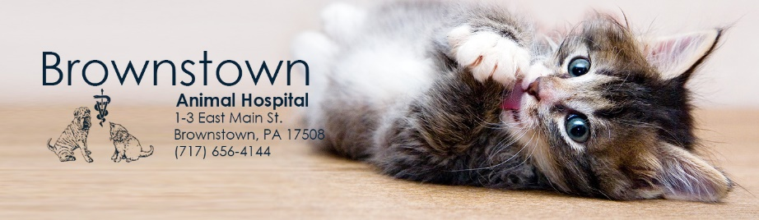

Our family-oriented staff is committed to providing you with state of the art veterinary care while maintaining an atmosphere of respect, support, and continued education.

Our family-oriented staff is committed to providing you with state of the art veterinary care while maintaining an atmosphere of respect, support, and continued education.

814 Dawn Ave. Ephrata, PA 17522

Schedule Your Appointment Today
717-733-7971

814 Dawn Ave. Ephrata, PA 17522

Schedule Your Appointment Today
717-733-7971

